Data Analytics with Tableau

Name: Mirza Tahseen Raza
Team member- 4
Assignment -1

Supermarket Sales Data Analysis Report – Tableau Visualizations

- Bar Chart: Total Sales by Product line
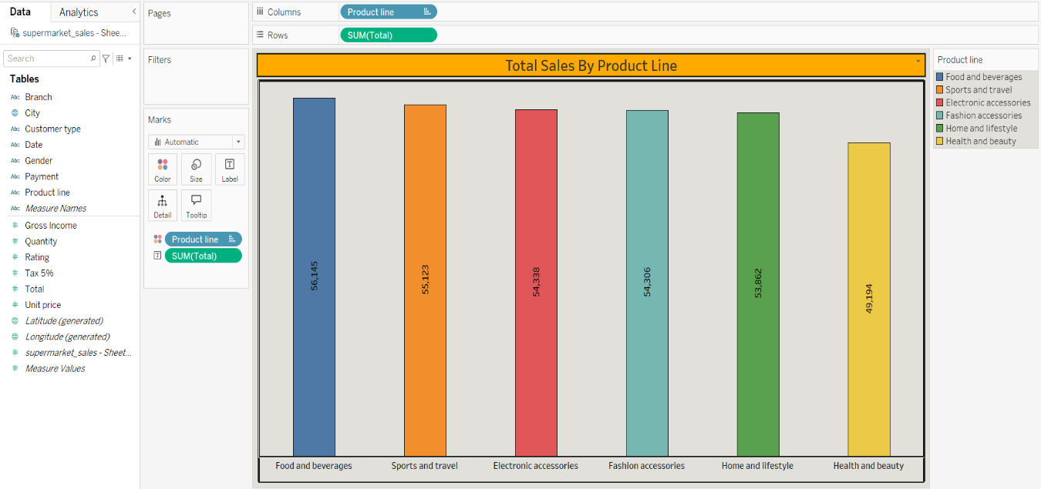
  - Sum of Total for each Product line. Colour shows details about Product line. The marks are labelled by sum of Total.

- Pie Chart: Payment Method Distribution
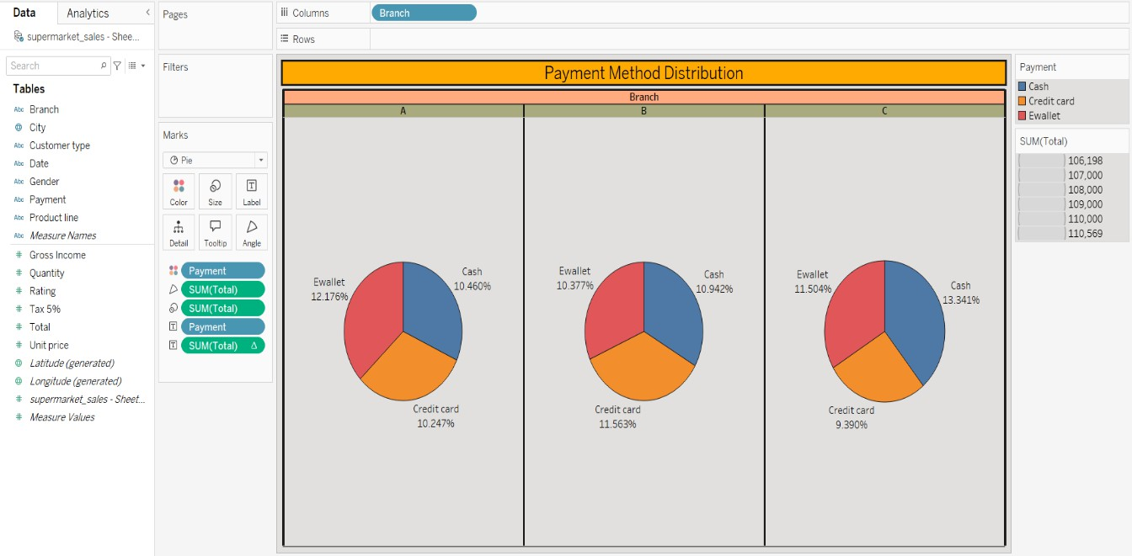
  - Payment and % of Total Total broken down by Branch. Color shows details about Payment. Size shows sum of Total. The marks are labeled by Payment and % of Total Total.

- Stacked Bar Chart: Sales by Branch & Product Line
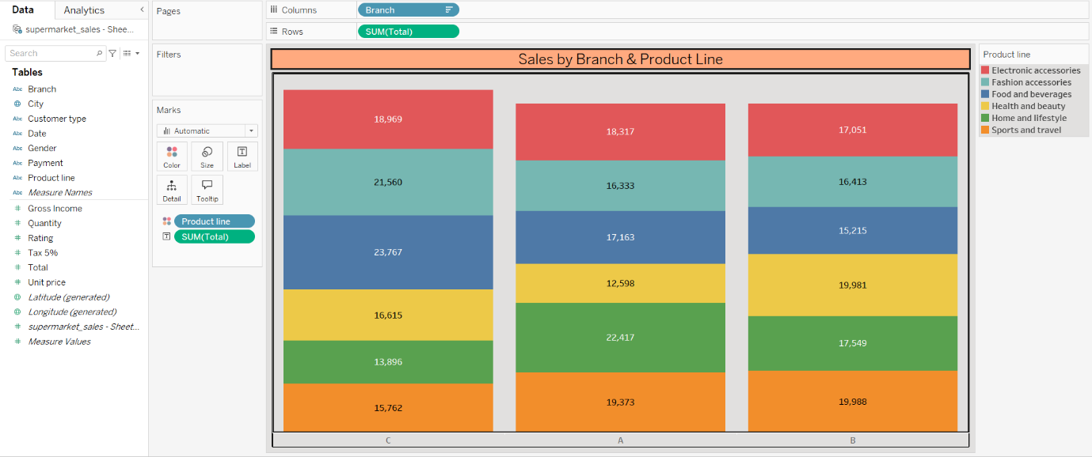
  - Sum of Total for each Branch. Colour shows details about Product line. The marks are labelled by sum of Total.

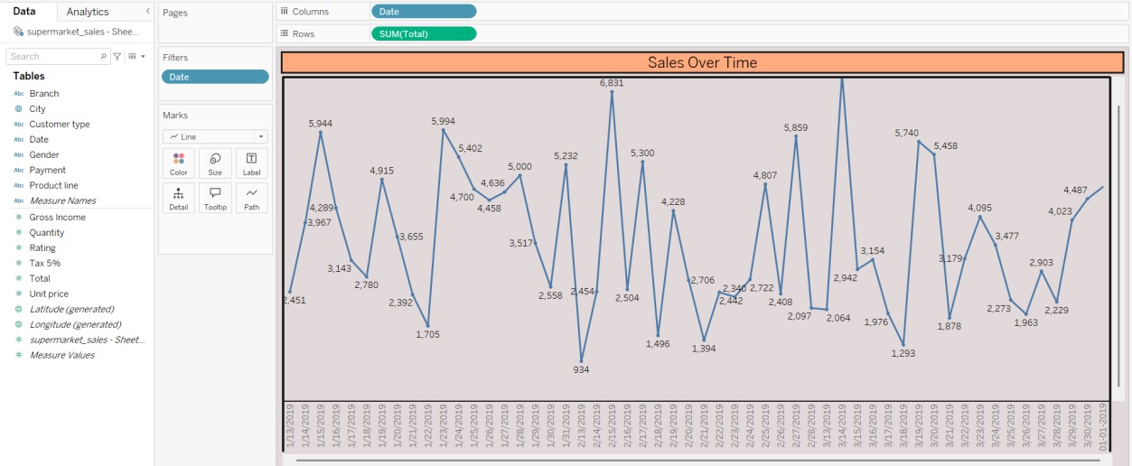
- Line Chart: Sales Over Time

  - The trend of sum of Total for Date. The view is filtered on Date, which keeps 54 of 89 members.
- Bubble Chart: Product Line v/s Total by Branch
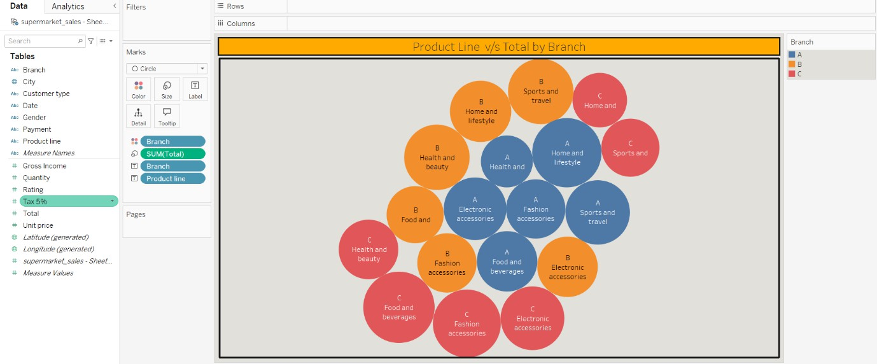
  - Branch and Product line. Colour shows details about Branch. Size
shows sum of Total. The marks are labelled by Branch and Product line.

